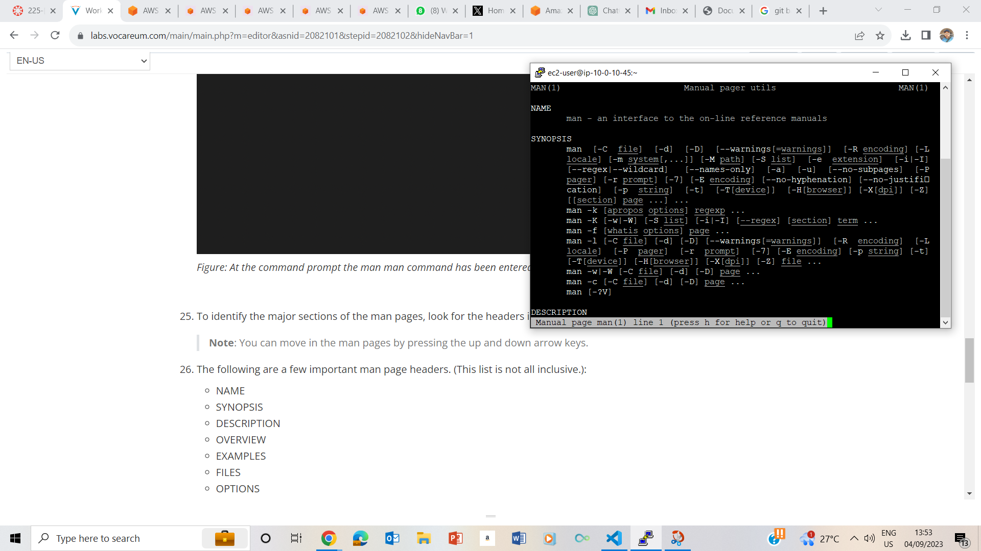

STEP 2 – LAUNCHING